INNOVA JUNIOR COLLEGE
JC 2 PRELIMINARY EXAMINATION 2
in preparation for General Certificate of Education Advanced Level
Higher 2

CANDIDATE
NAME

CLASS INDEX NUMBER

BIOLOGY  Paper 1 Multiple Choice  Additional Materials: Multiple Choice Answer Sheet | 9648/01, 9747/01  22 September 2010  1 hour 15 min

READ THESE INSTRUCTIONS FIRST

Write your name and class on all the work you hand in.
Write in soft pencil.
Do not use staples, paper clips, highlighters, glue or correction fluid.

There are forty questions on this paper. Answer all questions. For each question there are four possible answers A, B, C and D.
Choose the one you consider correct and record your choice in soft pencil on the separate Answer Sheet.

Read the instructions on the Answer Sheet very carefully.

Each correct answer will score one mark. A mark will not be deducted for a wrong answer.
Any rough working should be done in this booklet.
Calculators may be used.

This document consists of 18 printed pages.
 | Innova Junior College | [Turn over

1 | Which description of the characteristics of prokaryotic and eukaryotic cells is correct?
   | prokaryotic cells | eukaryotic cells
   | absence of mitochondria, can only undergo anaerobic respiration | mitochondria present, undergoes aerobic or anaerobic respiration
   | absence of ribosomes | presence of membrane-bound organelles
   | unicellular | multiple cellular
   | circular DNA | linear DNA
2 | A piece of mammalian tissue was homogenised and subjected to differential centrifugation to yield four subcellular fractions. The activity within each fraction, of four different types of enzyme, A, B, C and D, was investigated.  Which bar chart shows the results of investigating hydrolytic enzyme activity?  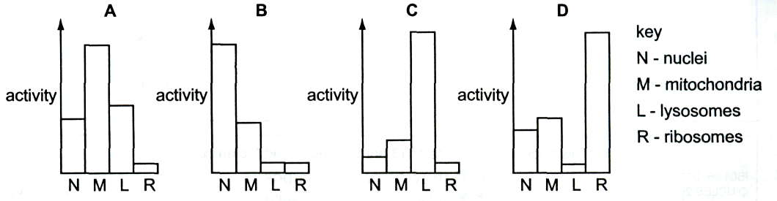
3 | At which levels of protein structure do hydrophobic interactions occur?  - primary, secondary and tertiary  - secondary, tertiary and quaternary  - tertiary and quaternary  - quaternary only

4 | Some germinating seeds are crushed with water and the extract is tested. The table shows the results of these tests.  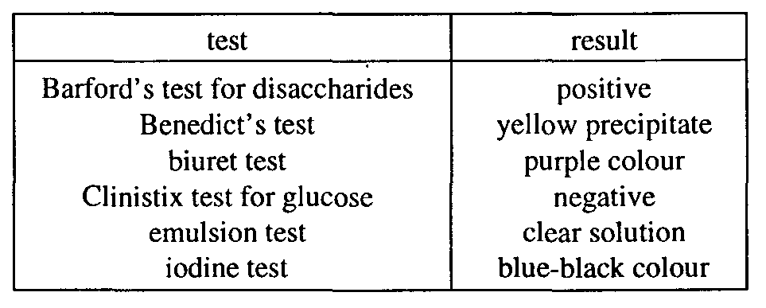  Which molecules are present in the extract?  - fat, maltose, starch only  - fat, protein, sucrose only  - glucose, protein, starch only  - maltose, protein, starch only
5 | The graph shows the effect of an enzyme on a reaction.  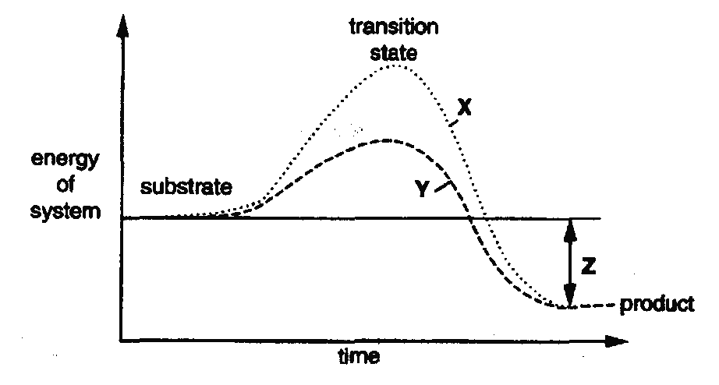  Which combination identifies X, Y and Z?
   | X | Y | Z
   | catalysed reaction | uncatalysed reaction | activation energy
   | catalysed reaction | uncatalysed reaction | energy lost during reaction
   | uncatalysed reaction | catalysed reaction | energy lost by product
   | uncatalysed reaction | catalysed reaction | overall energy change

6 | A culture of bacteria produces the food supplement lysine by the metabolic pathway shown.  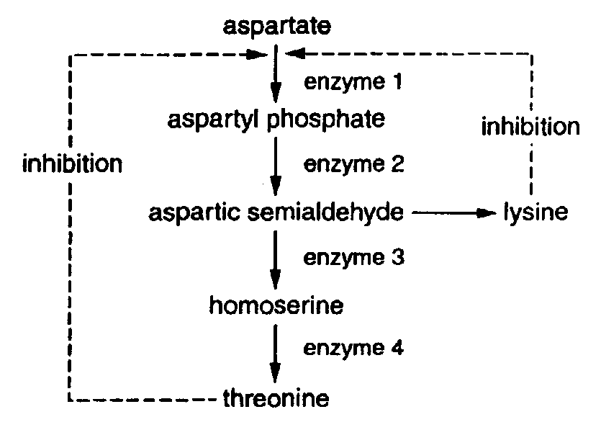  Which change in enzyme activity will result in the greatest increase in lysine yield?  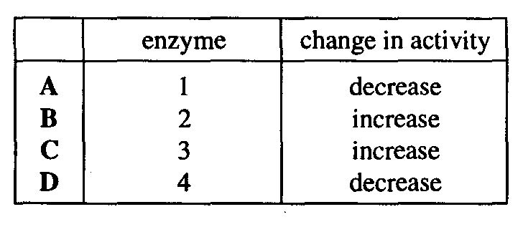
7 | The diagram shows some chromosomes at late prophase of mitosis.  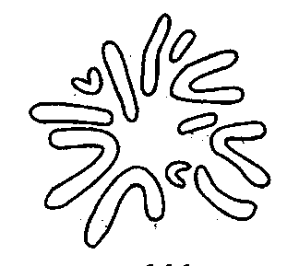  How many chromosomes would be present in one nucleus at telophase II of meiosis?  - 6  - 12  - 18  - 24

8 | The presence of starch in maize pollen grains is controlled by a pair of alleles at a single gene locus. One allele codes for the presence while the other allele results in the absence of starch. Half of the pollen grains of a heterozygous maize plant are found to contain starch. This is because  - half the pollen are heterozygous while the other half homozygous.  - the alleles are codominant to each other.  - the alleles separate at meiosis during anaphase I and II.  - the genes interact with each other.
9 | The diagram represents an anticodon.  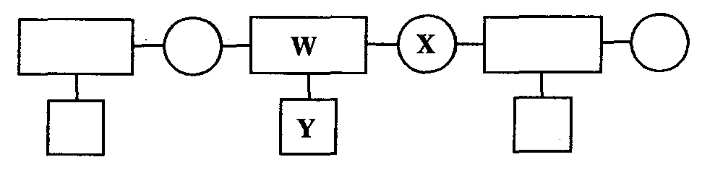  What do W, X and Y represent?  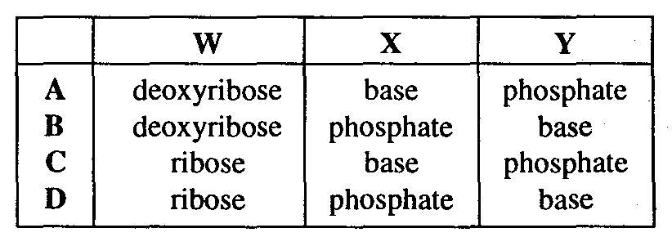
10 | How many different polypeptides, each consisting of r amino acids, can be made if the number of different amino acids available is n?  - n^{r}  - r^{n}  - nr  - n
11 | The table shows the percentages of nitrogenous bases in four samples of nucleic acids. Which base is adenine?  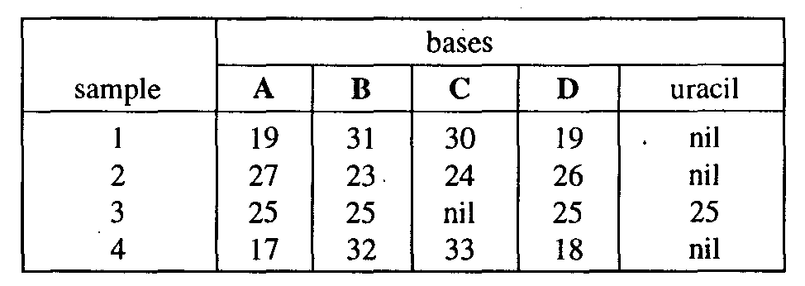
12 | Bacteria grown in ¹⁵N for many generations were transferred to ¹⁴N for further replication. DNA from the bacteria was extracted and separated by density gradient centrifugation.  Their results are summarised in the following diagram.  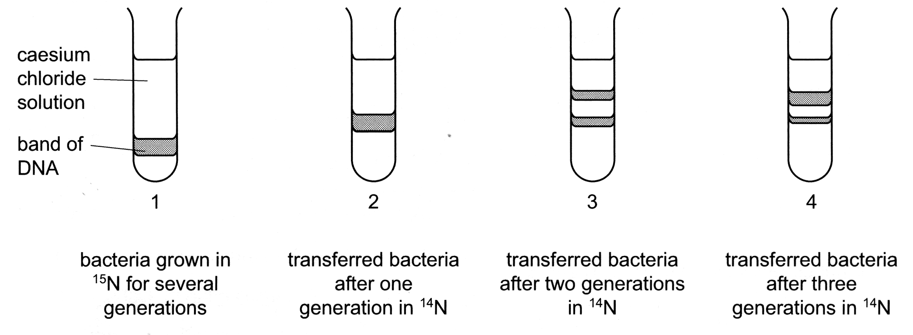  What are the percentages of DNA containing ¹⁵N and ¹⁴N in tube 4?  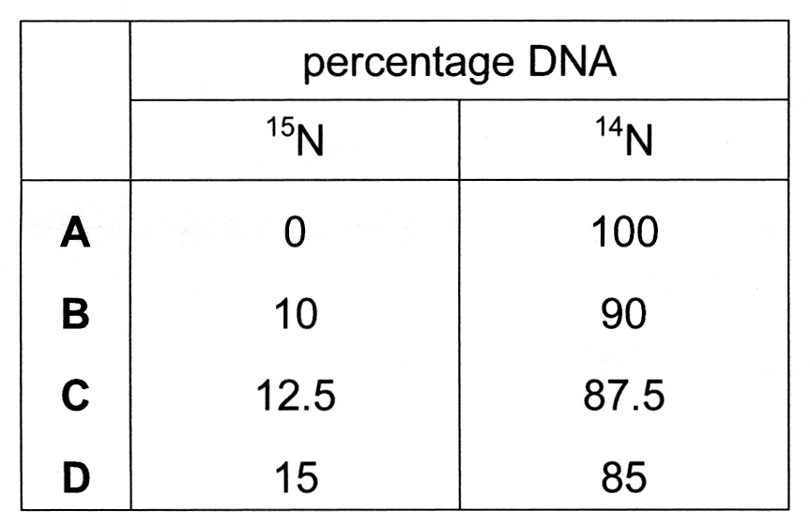
13 | A mutation of a gene coding for an ion pump in cell surface membranes results in the substitution of one amino acid, arginine, by another, histidine.  The DNA triplet codes for the two amino acids are shown.  arginine GCA histidine GTA  GCG GTG  GCT  GCC  TCT  TCC  Which mutation has occurred in the DNA?  - Addition of an extra nucleotide.  - Replacement of a nucleotide with a purine base by one with a different purine base.  - Replacement of a nucleotide with a purine base by one with a pyrimidine base.  - Replacement of a nucleotide with a pyrimidine base by one with a different pyrimidine base.
14 | Some people are genetically predisposed to suffer from particular diseases. The table shows some diseases and their causes.  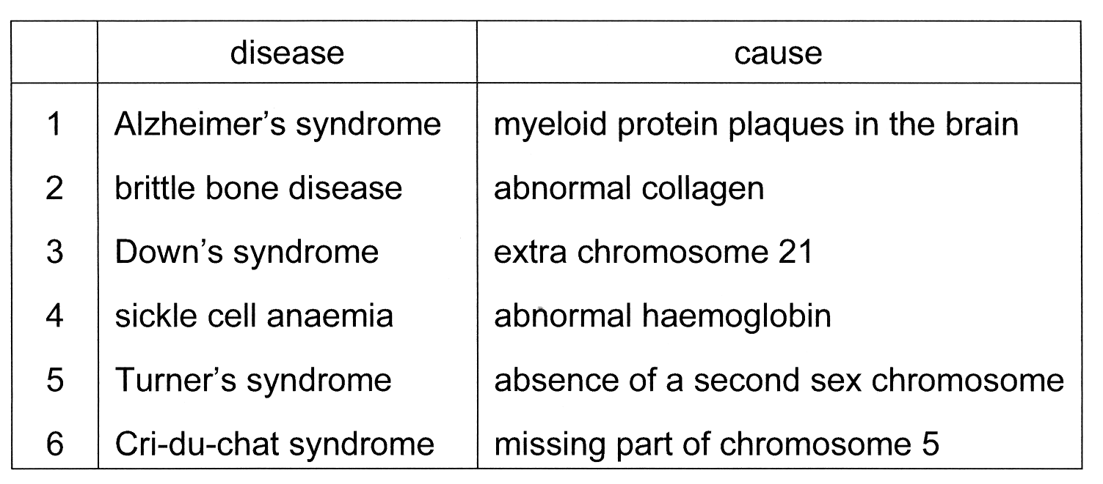  Which diseases are caused by gene mutation and which by chromosome aberration?  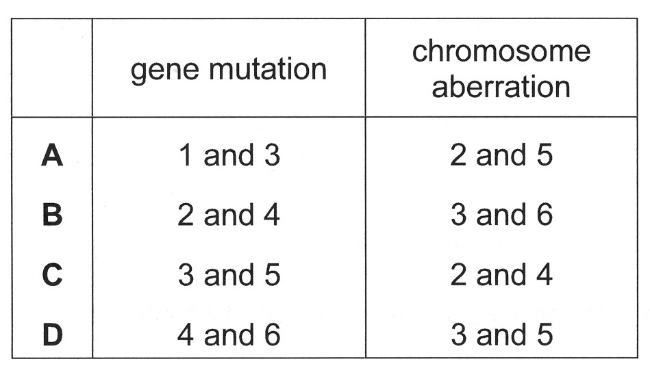
15 | The influenza virus is an enveloped virus with an RNA nucleocapsid. It enters a host cell by endocytosis and new viruses emerge by budding.  Some events that take place during the reproductive cycle are listed.  - The virus enters the cytoplasm surrounded by a coated vesicle.  - The nucleocapsid is released and viral RNA replicated by RNA polymerase.  - Each replicated viral RNA is given a new envelope.  - Viral haemagglutinin proteins bind to receptors on the host cell surface membrane.  - Haemagglutinin and neuraminidase are produced by the host cell’s ribosomes.  - The replicated viral RNA is transcribed to mRNA.  Which sequence of events correctly describes the reproductive cycle of the virus?  - 1  2  3  6  5  4  - 1  2  6  5  4  3  - 4  2  5  1  6  3  - 4  1  2  6  5  3
16 | The diagram represents the structure of the human immunodeficiency virus (HIV).  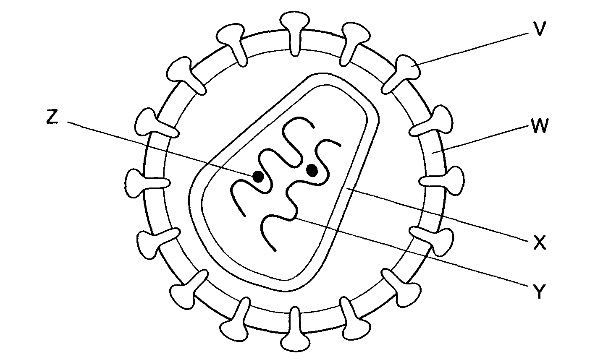  Which combination correctly identifies the chemical constituents of the lettered components?  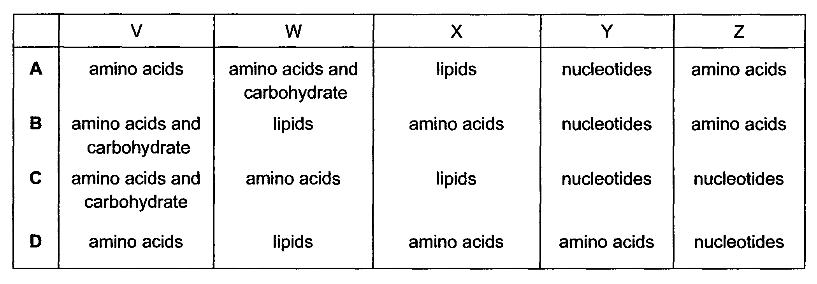
17 | During the development of the AIDS virus, a long polypeptide is hydrolysed by a protease enzyme, producing several smaller peptides. This viral enzyme is the target of new anti-AIDS drugs.  Which feature is essential for the success of these drugs?  - A complex structure that inhibits many types of viral enzyme.  - A molecule containing a heavy metal atom that is a non-competitive inhibitor of enzymes.  - A protein that can act as a competitive inhibitor of protease enzymes.  - A specific structure that inhibits only viral protease.

18 | Some events that take place during generalized transduction are listed below.  I Bacterial host DNA is fragmented.  II Bacterial DNA may be packaged in a phage capsid.  III Recombination between donor DNA and recipient DNA.  IV Phage infects bacterial cell.  V Phage DNA and proteins are made.  Which sequence of events is correct?  First Last  - IV I III V II  - IV I V II III  - IV III I V II  - IV V I III II
19 | Which correctly describes the transfer of DNA from one bacterium to another?
   | binary fission | conjugation | transformation
  A | bacterial chromosome and plasmids pass to daughter cells | double strand of F plasmid transferred from one bacterium to another | bacterial cells takes up 1 strand of foreign DNA from culture medium
  B | bacterial chromosome and plasmids pass to daughter cells | single strand of F plasmid transferred from one bacterium to another | bacterial cells takes up 1 strand of foreign DNA from culture medium
  C | only chromosomes passed to daughter cells | single strand of F plasmid transferred from one bacterium to another | bacterial cells takes up 2 strands of foreign DNA from culture medium
  D | only plasmids passed to daughter cells | double strand of F plasmid transferred from one bacterium to another | bacterial cells takes up 2 strands of foreign DNA from culture medium
20 | The diagram shows a short length of DNA from E. coIi with associated molecules 1 - 4 which are involved in the lac operon mechanism.  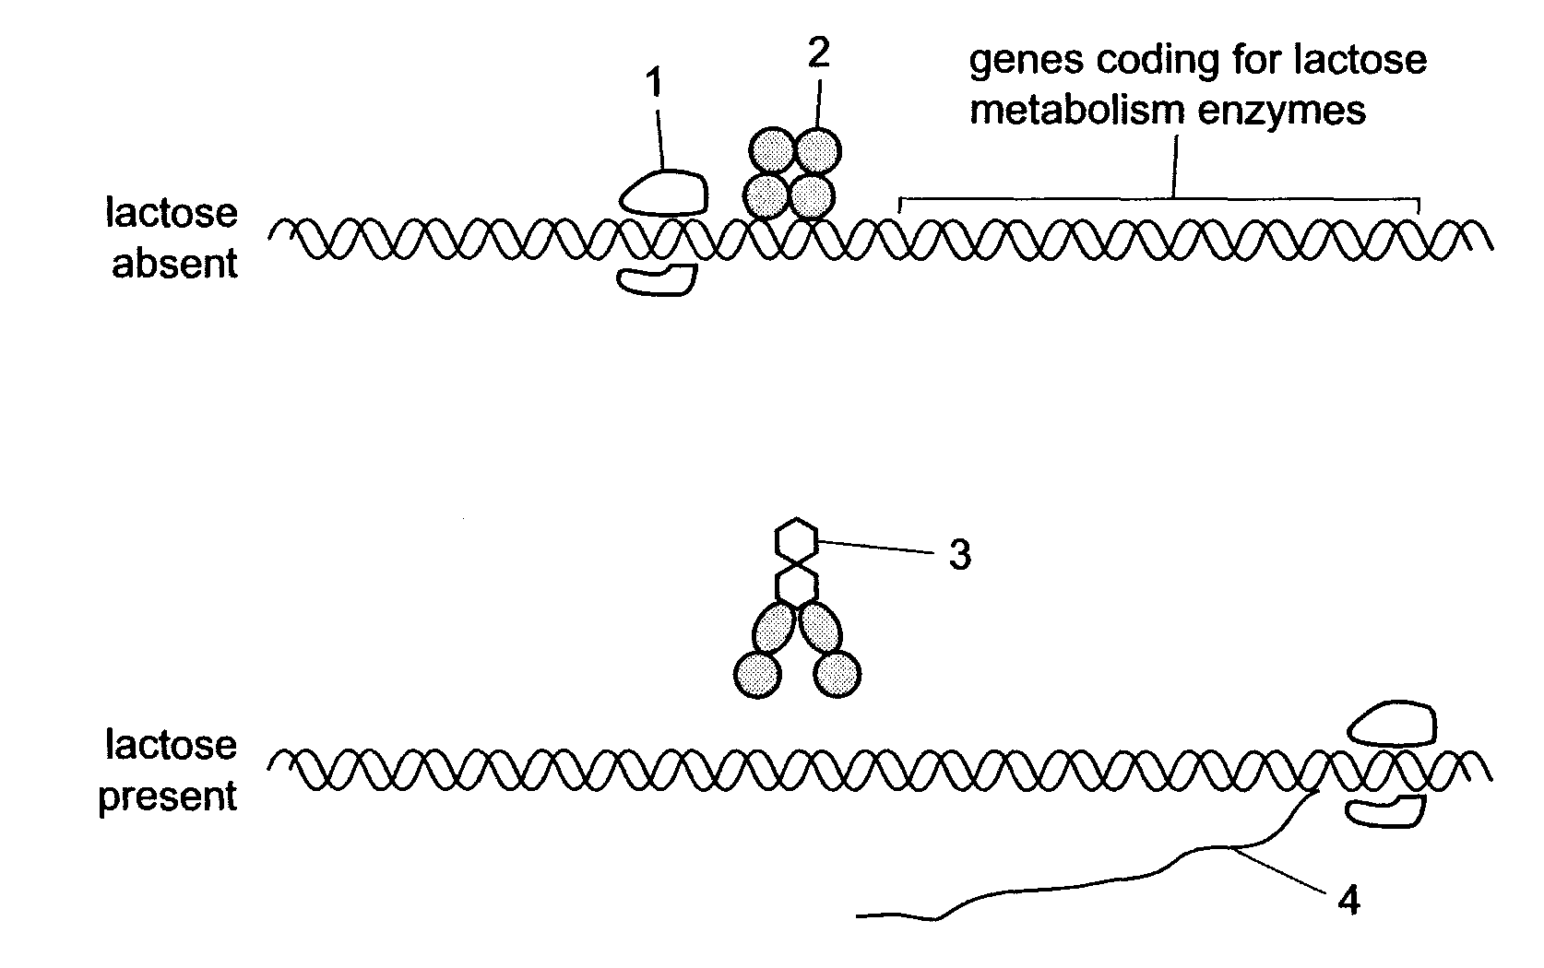  Which is the correct combination for molecules 1 - 4?  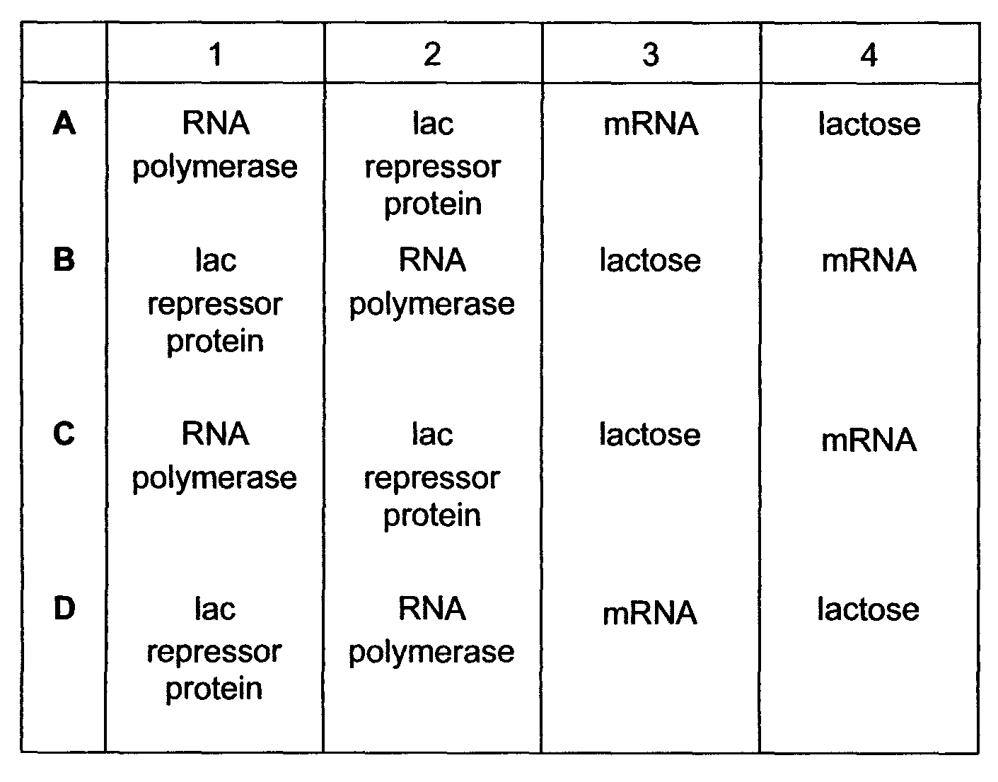

21 | The processing of pre-mRNA involves the following steps to produce functional mRNA.  - polyadenylation  - removal of introns  - splicing of exons  - capping  In which order do they occur?  - 1  3  2  4  - 2  4  1  3  - 3  1  4  2  - 4  2  3  1
22 | When a person undergoes a stressful experience, their immune system can be depressed and they become more susceptible to infection. Some of the elements involved in this chain of events are shown in the diagram below.  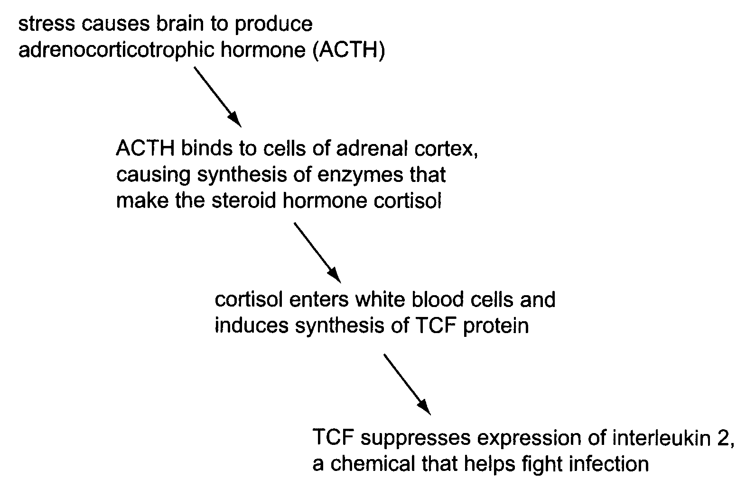  Which combination correctly shows the genes that have transcription-enhancing factors bound to their control elements during the above sequence of events?  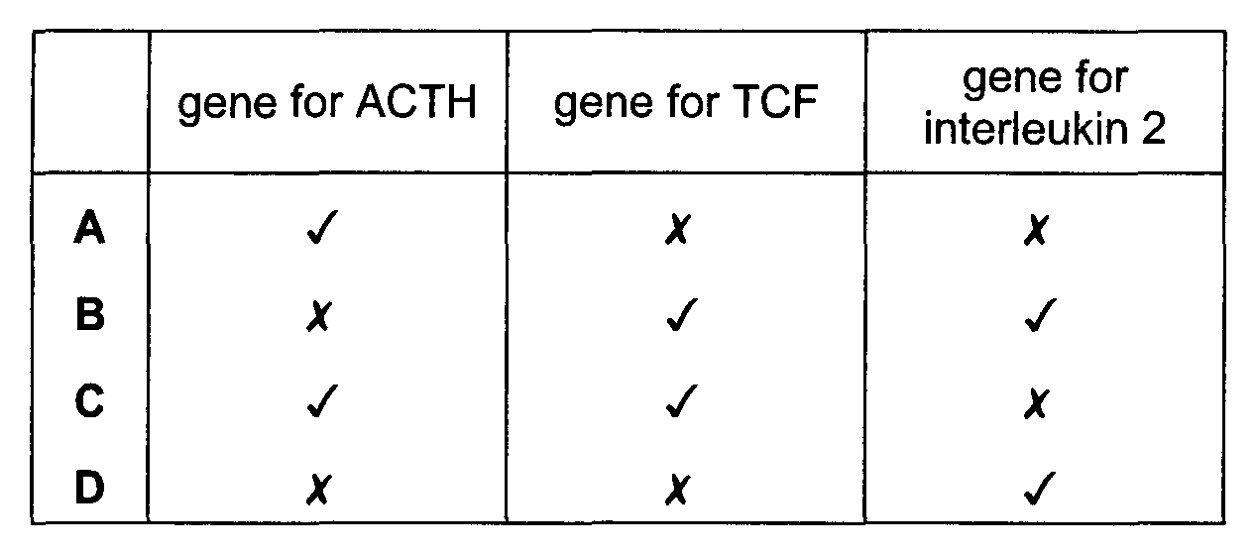
23 | Which of the following is an example of a possible step in the post-transcriptional control of gene expression?  - The addition of methyl groups to cytosine bases of DNA.  - The binding of transcription factors to a promoter.  - The removal of introns and splicing together of exons.  - Gene amplification during a stage in development.
24 | Four different genes are regulated in different ways.  Gene 1 undergoes tissue-specific patterns of alternative splicing.  Gene 2 is part of a group of structural genes controlled by the same regulatory sequences.  Gene 3 under some circumstances undergo methylation.  Gene 4 codes for a repressor protein which acts at an operator site close by.  Which row of the table correctly identifies which genes are prokaryotic and which are eukaryotic?  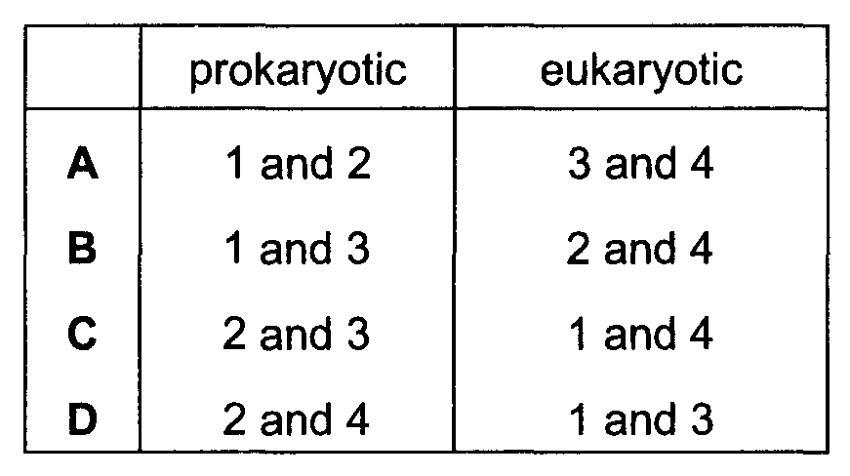
25 | A tall, pink-flowered plant is self-fertilised and produces the offspring shown.  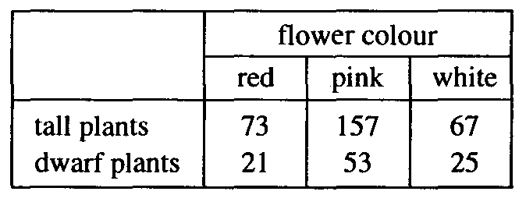  When self-fertilised, which type of plant will only produce identical offspring?  - dwarf, pink-flowered  - dwarf, white-flowered  - tall, red-flowered  - tall, white-flowered
26 | The diagram shows the inheritance of haemophilia in a family.  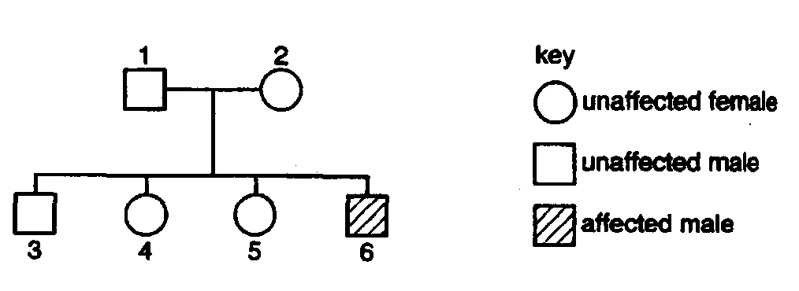  If daughter 4 married a normal male, what is the probability that their first child would suffer from haemophilia?  - 0  - 0.125  - 0.25  - 0.5
27 | A test cross was done on a tall, red-stemmed plant with genotype TtRR. A χ² test was carried out on the results obtained for the progenies. Part of the table of values for χ² is shown.  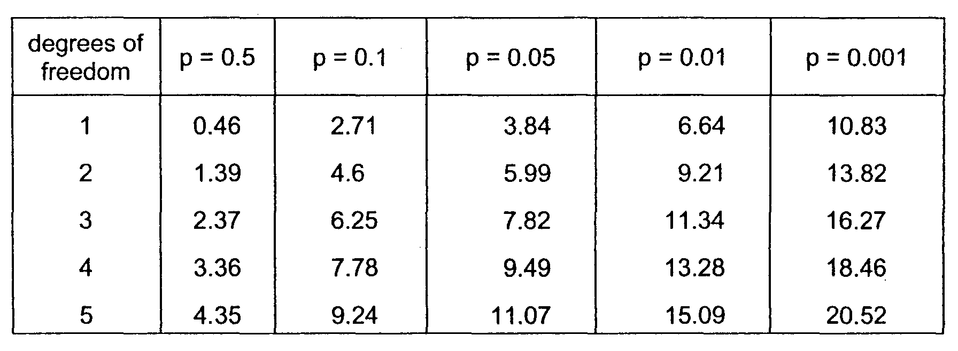  The value of χ² in this investigation was 8.0.  What is the probability of this value of χ² and do the results fit the expected ratio?
   | probability | Results fit expected ratio
  A | between 0.001 and 0.01 | no
  B | between 0.01 and 0.05 | no
  C | between 0.05 and 0.1 | yes
  D | between 0.1 and 0.5 | yes
28 | Which of the following process is the link between the light dependent and the light independent stages of photosynthesis?  - Photolysis of water  - Photoactivation of reaction centre  - Production of RuBP  - Production of NADPH and ATP
29 | Four test-tubes were set up as shown.  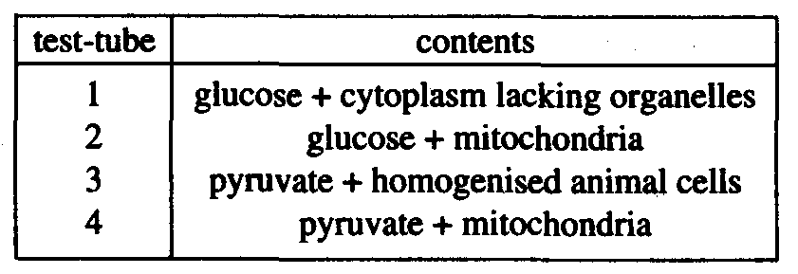  After incubation, each sample was analysed to determine the presence of lactate. In which test-tube is lactate most likely to be present?  - 1  - 2  - 3  - 4
30 | The graph shows a patient with diabetes who consumes a meal rich in carbohydrates. The concentrations of glucose and insulin in the blood stream were monitored for five hours after the meal. The glucose concentration is measured in mg 100 cm⁻³ and the insulin concentration in arbitrary units.  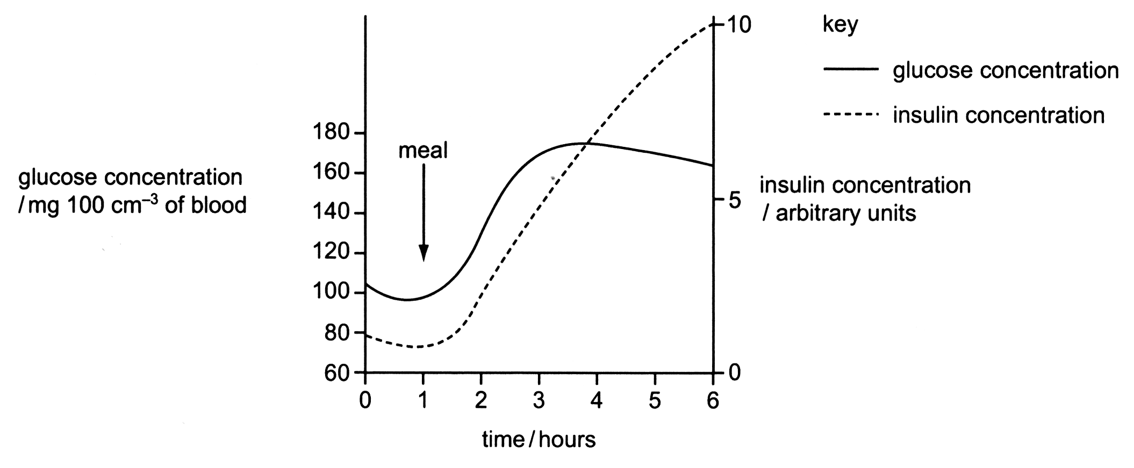  What would be an effective treatment for this patient?  - injection of insulin before a meal  - reduction of dietary carbohydrate  - use of a glucagon inhibitor  - use of a diuretic to increase urine production
31 | The diagram represents a transverse section through a neurone as seen under an electron microscope. Which of the following most appropriately describes the function of X?  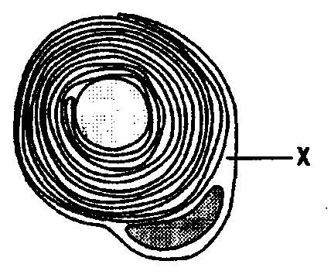  - Insulate the neurone to maintain homeostatic conditions.  - Provide mechanical protection to the axon.  - Prevents ion exchange between the axon and extracellular fluid.  - Speeds up nervous transmission by allowing impulse to travel along it.
32 | The diagram represents a G-protein coupled receptor on the cell surface membrane. A peptide hormone ligand is bound to the receptor and initiates the production of a second messenger.  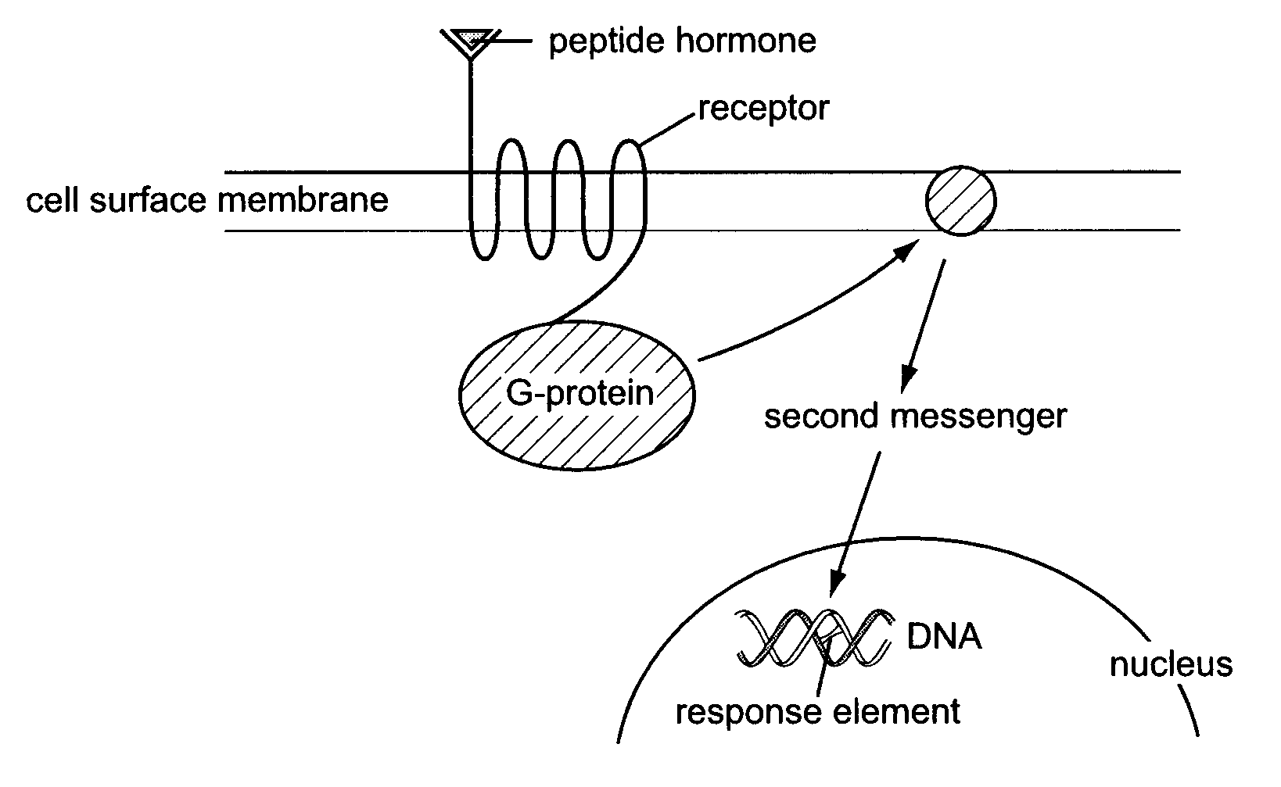  What is the second messenger?  - a peptide hormone  - ATP  - cyclic AMP  - kinase

33 | Which one of the following statements about natural selection is incorrect?  Natural selection may  - cause new genes to appear in a gene pool.  - occur in stable environmental conditions.  - result in an increase in the frequency of favourable genes in a gene pool.  - result in an increase in the percentage of well-adapted individuals in a population.
34 | What does the neutral theory of molecular evolution suggest about many mutations?  - They are not affected by mutagens.  - They are not influenced by natural selection.  - They occur in non-coding parts of the genome.  - They only affect diploid organisms.
35 | DNA–DNA hybridisation is a technique used to determine the similarity of DNA from different species.  In this technique:  - DNA is extracted from different species and cut into pieces using special enzymes;  - the DNA is heated to separate the double strands into single strands;  - single strands of DNA from different species are mixed together and cooled so that double strands of hybrid DNA form.  The following table shows the temperature (°C) needed to separate the hybrid DNA strands of four different species, Q, R, S, and T:  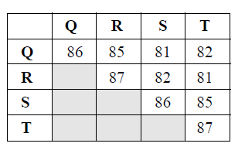  Which one of the following statements is supported by the data provided?  - Q is more closely related to R than S is to T.  - Q is more closely related to S than it is to R or T.  - S is more closely related to R than Q is to T.  - S is more closely related to T than it is to R or Q.
36 | Which of the following shows the correct sequence of events for producing human growth hormone (hGH) using the bacterium E. coli?
 | 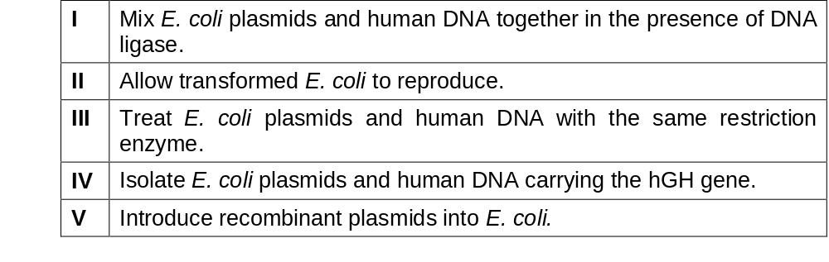
- IV, I, III, V, II
- IV, III, I, V, II
- IV, III, V, I, II
- V, IV, I, III, II

37 | The diagram shows the results of electrophoresis of DNA fragments from four members of a family R, S, V, W and another male X, who claims that he is actually the father of person R.  Which bands on the electrophoretogram indicate that person V is the father of person R?  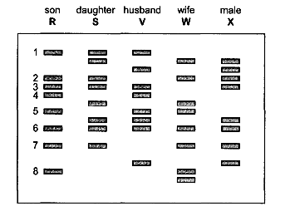  - 1 and 2  - 1 and 4  - 2 and 7  - 3 and 6

38 | The completion of the Human Genome Project revealed that the human genome contains fewer genes than expected, not so many more than simpler organisms. Which of the following statements could explain this phenomenon?  - RNA transcripts of human genes are more likely to undergo alternative splicing.  - Polypeptide domains are combined in a variety of ways.  - Post-translational processing adds diversity to the resulting polypeptides.  - Gene expression patterns in humans are often more complex than those in other organisms.
- 1 only
- 1 and 2
- 2, 3 and 4
- 1, 2, 3 and 4

39 | Embryonic stem cells offer great promise to the cure of many diseases because  i they are pluripotent.  ii they are more readily available than other cells.  iii they can be easily cultured in vitro.  iv they will differentiate and produce cells which are normal.  Which of the following is/are true?  - i, iv  - i, iii, iv  - ii, iii, iv  - iv only
40 | Each of the statement is concerned with the success or failure of gene therapy as a permanent cure for genetic disorders.  - Somatic cells cannot pass the modified gene on to any offspring.  - The treatment does not last long as the treated cells die and are replaced.  - The treatment does not result in all cells having the therapeutic gene.  Which statement(s) explain the limited success of gene therapy as a permanent cure for genetic disorders in human population?  - 1 only  - 1 and 3  - 2 and 3  - 1, 2 and 3

2010 JC2 Prelim Exam II
H2 Biology Paper 1

Qn | Answer | Qn | Answer | Qn | Answer | Qn | Answer
1 | D | 11 | B | 21 | D | 31 | C
2 | C | 12 | C | 22 | C | 32 | C
3 | C | 13 | D | 23 | C | 33 | A
4 | D | 14 | B | 24 | D | 34 | B
5 | D | 15 | D | 25 | B | 35 | D
6 | D | 16 | B | 26 | B | 36 | B
7 | A | 17 | D | 27 | A | 37 | B
8 | C | 18 | B | 28 | D | 38 | D
9 | D | 19 | B | 29 | A | 39 | A
10 | A | 20 | C | 30 | B | 40 | D

